Technical Specification Form

SAP Production Order Data

**Technical specification content**

1. Business Requirement
2. Development Tools
3. Development Objects

* Table.
* CDS Data Definition.
* CDS Access Control.
* SEGW – OData Project.

1. Business API / OData API and Output Screen

SAP Technical Specification Form

|  |  |  |  |
| --- | --- | --- | --- |
| User Story ID # | 9000RUPESH | Module | PP |
| Date | 09-07-2025 | SL User |  |
| Consultant |  | Developer | Debidutta swain |
| Priority | ☐Urgent ☐High ☒Medium ☐Low | | |
| Application Type | ☐Report ☐Form ☐Interface ☒ODATA ☐Others | | |
| Execute Model | ☐Batch ☐ Foreground ☐Manual ☐Quarterly ☐Monthly  ☐Weekly ☐ Daily ☒Real time | | |
| Output Type | ☐Message ☐Dialog Screen ☐ABAP List ☒List View ☐ALV Grid | | |
| Remarks | SAP Production Order Data | | |

1. **Business Requirement:**

Develop an OData GET API for Production Order data, through which Business user can check Production Order data in External SAP application. In the External SAP application, user can able to see following details in a List view manner. Also, if user want to see the component and Routing Details of the Production order then they can click on the component/routing button at the UI application and able the see those details of a single production Order at a time for that also separate API Prepared .



**2.Development Status & Tools**

For development these are the following tool used :

* **Eclipse for ABAP /ADT(ABAP Development Tool)**
* Interface/Basic CDS view:

Created on top of Required Database. Naming convention: ZI_*****

* Composite CDS view:

Created on top of Interface basic view for join/association. Naming convention: ZCO_*****

* Consumption view:

Expose only those field required for Business Requirement. Naming convention: ZC_*****

* Access Control:  
  In order to Maintain Access on the data. Naming Convention : ZDCL_******
* **SEGW OData Project**
* Created OData project with “Data Source Reference” Using the consumption CDS view. Here in this CDS association has been done due to which in ODATA project all the association and navigation property generate automatically.
* For Service Registration used Tcode : /O/IWFND/MAINT_SERVICE.
* To Check the final data at Gateway Client used Tcode :/O/IWFND/GW_CLIENT.

NOTE: For CDS development process, I followed the VDM approach.

**3.Development Objects**

* Table:
* **AFKO:** Order Header Data PP Orders
* **AFUK:** Order master Data
* **AFVC:** Operation within an order
* **RESB:** Reservation/dependent requirements
* **CDS Data Definition:**
* **Basic CDS View:**

As I am following the VDM modeling in this development, I had created Basic CDS view on top of Database table and the source of Basic View Should be a Database View or Standard CDS view.

* **AFKO:** Order Header Data PP Orders

CDS Name: ZI_PP_AFKO_OrderHeaderData

* @AbapCatalog.sqlViewName: 'ZIAFKO'
* @AbapCatalog.compiler.compareFilter: true
* @AbapCatalog.preserveKey: true
* @AccessControl.authorizationCheck: #NOT_REQUIRED
* @EndUserText.label: 'Basic CDS:AFKO:Order Header Data PP Orders'
* @Metadata.ignorePropagatedAnnotations: true
* @VDM.viewType: #BASIC
* **define** **view** ZI_PP_AFKO_OrderHeaderData
* **as** **select** **from** afko
* **{**
* **key** aufnr **as** OrderNumber**,**
* gltrp **as** BasicFinishDate**,**
* gstrp **as** BasicStartDate**,**
* ftrmi **as** ActualReleaseDate**,**
* rsnum **as** NumberOfReservation**,**
* gamng **as** TotalOrderQuantity**,**
* gmein **as** BaseUOM**,**
* plnbez **as** MaterialCode**,**
* plnty **as** TaskListType**,**
* plnnr **as** KeyTaskListGroup**,**
* plnal **as** GroupCounter**,**
* stlnr **as** BillOfMaterial**,**
* aufpl **as** OrderRoutingNumberOperation
* **}**
* **AFUK:** Order master Data

CDS view name: ZI_PP_AUFK_OrderMasterData

* @AbapCatalog.sqlViewName: 'ZIAUFK'
* @AbapCatalog.compiler.compareFilter: true
* @AbapCatalog.preserveKey: true
* @AccessControl.authorizationCheck: #NOT_REQUIRED
* @EndUserText.label: 'Basic CDS:AUFK:Order master data'
* @Metadata.ignorePropagatedAnnotations: true
* @VDM.viewType: #BASIC
* **define** **view** ZI_PP_AUFK_OrderMasterData
* **as** **select** **from** aufk
* **{**
* **key** aufnr **as** OrderNumber**,**
* auart **as** OrderType**,**
* autyp **as** OrderCategory**,**
* ernam **as** EnteredBy**,**
* erdat **as** CreatedOn**,**
* aenam **as** ChangedBy**,**
* aedat **as** ChangedOn**,**
* bukrs **as** ComapnyCode**,**
* werks **as** Plant**,**
* kokrs **as** ControllingArea**,**
* prctr **as** ProfitCenter**,**
* erfzeit **as** TimeCreated**,**
* aezeit **as** ChangedAt
* **}**

* **AFVC**: Operation within an order

CDS view name: ZI_PP_AFVC_OrderOperation

* @AbapCatalog.sqlViewName: 'ZIAFVC'
* @AbapCatalog.compiler.compareFilter: true
* @AbapCatalog.preserveKey: true
* @AccessControl.authorizationCheck: #NOT_REQUIRED
* @EndUserText.label: 'Basic CDS:AFVC:Operation within an order'
* @Metadata.ignorePropagatedAnnotations: true
* @VDM.viewType: #BASIC
* **define** **view** ZI_PP_AFVC_OrderOperation
* **as** **select** **from** afvc
* **{**
* **key** aufpl **as** OrderRoutingNumberOperation**,**
* **key** aplzl **as** GeneralCounterForOrder**,**
* steus **as** ControlKey**,**
* arbid **as** ObjectID**,**
* ktsch **as** StandardTextKey
* **}**
* **RESB:** Reservation/dependent requirements

CDS view name: ZI_PP_RESB_Requirment

* @AbapCatalog.sqlViewName: 'ZIRESB'
* @AbapCatalog.compiler.compareFilter: true
* @AbapCatalog.preserveKey: true
* @AccessControl.authorizationCheck: #NOT_REQUIRED
* @EndUserText.label: 'Basic CDS:RESB:Reservation/dependent requirements'
* @Metadata.ignorePropagatedAnnotations: true
* @VDM.viewType: #BASIC
* **define** **view** ZI_PP_RESB_Requirment
* **as** **select** **from** resb
* **left** **outer** **join** makt **on** makt**.**matnr **=** resb**.**matnr
* **and** makt**.**spras **=** **$session.system_language**
* **left** **outer** **join** t001l **on** t001l**.**werks **=** resb**.**werks
* **and** t001l**.**lgort **=** resb**.**lgort
* **left** **outer** **join** t001w **on** t001w**.**werks **=** resb**.**werks
* **{**
* **key** resb**.**aufnr **as** OrderNumber**,**
* **key** resb**.**posnr **as** BOMItemNumber**,**
* resb**.**postp **as** ItemCatagory**,**
* resb**.**rsnum **as** ReservationNumber**,**
* resb**.**rspos **as** ReservationItem**,**
* resb**.**werks **as** Plant**,**
* t001w**.**name1 **as** PlantDescription**,**
* resb**.**lgort **as** StorageLocation**,**
* t001l**.**lgobe **as** StorageLocationDescription**,**
* resb**.**matnr **as** MaterialNumber**,**
* makt**.**maktx **as** MaterialDescripton**,**
* resb**.**bdmng **as** RequirementQuantity**,**
* resb**.**meins **as** UOM
* **}**

* **Composite CDS view**

As I am following the VDM modeling in this development, I had created Composite CDS view on top of Basic View where I will do all the necessary Joins/association needed for the Current Business Requirement.

CDS view name: ZCO_PP_AFKO_OrderHeaderData

* @AbapCatalog.sqlViewName: 'ZCOAFKO'
* @AbapCatalog.compiler.compareFilter: true
* @AbapCatalog.preserveKey: true
* @AccessControl.authorizationCheck: #NOT_REQUIRED
* @EndUserText.label: 'Composite View:AFKO:Order Header Data'
* @Metadata.ignorePropagatedAnnotations: true
* @VDM.viewType: #COMPOSITE
* **define** **view** ZCO_PP_AFKO_OrderHeaderData
* **as** **select** **from** ZI_PP_AFKO_OrderHeaderData **as** AFKO
* **left** **outer** **join** makt **on** makt**.**matnr **=** AFKO**.**MaterialCode
* **and** makt**.**spras **=** **$session.system_language**
* **inner** **join** ZCO_PP_AUFK_OrderMasterData **as** AUFK **on** AFKO**.**OrderNumber **=** AUFK**.**OrderNumber
* **{**
* **key** AFKO**.**OrderNumber**,**
* AFKO**.**BasicFinishDate**,**
* AFKO**.**BasicStartDate**,**
* AFKO**.**ActualReleaseDate**,**
* AFKO**.**NumberOfReservation**,**
* AFKO**.**TotalOrderQuantity**,**
* AFKO**.**BaseUOM**,**
* AFKO**.**MaterialCode**,**
* makt**.**maktx **as** MateriaDescription**,**
* AFKO**.**TaskListType**,**
* AFKO**.**KeyTaskListGroup**,**
* AFKO**.**GroupCounter**,**
* AFKO**.**BillOfMaterial**,**
* AFKO**.**OrderRoutingNumberOperation**,**
* AUFK**.**OrderType**,**
* AUFK**.**OrderCategory**,**
* AUFK**.**EnteredBy**,**
* AUFK**.**CreatedOn**,**
* AUFK**.**ChangedBy**,**
* AUFK**.**ChangedOn**,**
* AUFK**.**ComapnyCode**,**
* AUFK**.**Plant**,**
* AUFK**.**PlantName**,**
* AUFK**.**ControllingArea**,**
* AUFK**.**ProfitCenter**,**
* AUFK**.**TimeCreated**,**
* AUFK**.**ChangedAt
* **}**

CDS view name : ZCO_PP_AUFK_OrderMasterData

* @AbapCatalog.sqlViewName: 'ZCOAUFK'
* @AbapCatalog.compiler.compareFilter: true
* @AbapCatalog.preserveKey: true
* @AccessControl.authorizationCheck: #NOT_REQUIRED
* @EndUserText.label: 'Composite CDS:AUFK:Order master data'
* @Metadata.ignorePropagatedAnnotations: true
* @VDM.viewType: #COMPOSITE
* **define** **view** ZCO_PP_AUFK_OrderMasterData
* **as** **select** **from** ZI_PP_AUFK_OrderMasterData **as** Aufk
* **left** **outer** **join** t001w **on** t001w**.**werks **=** Aufk**.**Plant
* **{**
* **key** Aufk**.**OrderNumber**,**
* Aufk**.**OrderType**,**
* Aufk**.**OrderCategory**,**
* Aufk**.**EnteredBy**,**
* Aufk**.**CreatedOn**,**
* Aufk**.**ChangedBy**,**
* Aufk**.**ChangedOn**,**
* Aufk**.**ComapnyCode**,**
* Aufk**.**Plant**,**
* t001w**.**name1 **as** PlantName**,**
* Aufk**.**ControllingArea**,**
* Aufk**.**ProfitCenter**,**
* Aufk**.**TimeCreated**,**
* Aufk**.**ChangedAt
* **}**

CDS view name : ZCO_PP_AFVC_ORDEROPERATION

* @AbapCatalog.sqlViewName: 'ZCOAFVC'
* @AbapCatalog.compiler.compareFilter: true
* @AbapCatalog.preserveKey: true
* @AccessControl.authorizationCheck: #NOT_REQUIRED
* @EndUserText.label: 'Composite CDS:AFVC:Operation with in Order'
* @Metadata.ignorePropagatedAnnotations: true
* @VDM.viewType: #COMPOSITE
* **define** **view** ZCO_PP_AFVC_ORDEROPERATION
* **as** **select** **from** ZI_PP_AFVC_OrderOperation
* **{**
* **key** OrderRoutingNumberOperation**,**
* GeneralCounterForOrder**,**
* ControlKey**,**
* ObjectID**,**
* StandardTextKey
* **}**

CDS View name: ZCO_PP_RESB_REQUIRMENT

* @AbapCatalog.sqlViewName: 'ZCORESB'
* @AbapCatalog.compiler.compareFilter: true
* @AbapCatalog.preserveKey: true
* @AccessControl.authorizationCheck: #CHECK
* @EndUserText.label: 'Composite CDS:RESB:Reservation/dependent requirements'
* @Metadata.ignorePropagatedAnnotations: true
* @VDM.viewType: #COMPOSITE
* **define** **view** ZCO_PP_RESB_REQUIRMENT
* **as** **select** **from** ZI_PP_RESB_Requirment
* **{**
* **key** OrderNumber**,**
* **key** BOMItemNumber**,**
* ItemCatagory**,**
* ReservationNumber**,**
* ReservationItem**,**
* Plant**,**
* PlantDescription**,**
* StorageLocation**,**
* StorageLocationDescription**,**
* MaterialNumber**,**
* MaterialDescripton**,**
* RequirementQuantity**,**
* UOM
* **}**
* **Consumption CDS view**

As I am following the VDM modeling in this development, I had created Consumption CDS view on top of Composite CDS View where I had added all the field which are need to Expose as per the Business Requirement.

CDS view name: ZC_PP_ProductionOrderData

* @AbapCatalog.sqlViewName: 'ZCPRDCO'
* @AbapCatalog.compiler.compareFilter: true
* @AbapCatalog.preserveKey: true
* @AccessControl.authorizationCheck: #CHECK
* @EndUserText.label: 'Consuption View:Production Order Details'
* @Metadata.ignorePropagatedAnnotations: true
* @VDM.viewType: #CONSUMPTION
* **define** **view** ZC_PP_ProductionOrderData
* **as** **select** **from** ZCO_PP_AFKO_OrderHeaderData
* **association** **[**0**..*]** **to** ZCO_PP_AFVC_ORDEROPERATION **as** _Routing **on** **$projection.**OrderRoutingNumberOperation **=** _Routing**.**OrderRoutingNumberOperation
* **association** **[**0**..*]** **to** ZCO_PP_RESB_REQUIRMENT **as** _Component **on** **$projection.**OrderNumber **=** _Component**.**OrderNumber
* **{**
* **key** OrderNumber**,**
* BasicFinishDate**,**
* BasicStartDate**,**
* ActualReleaseDate**,**
* NumberOfReservation**,**
* TotalOrderQuantity**,**
* BaseUOM**,**
* MaterialCode**,**
* MateriaDescription**,**
* TaskListType**,**
* KeyTaskListGroup**,**
* GroupCounter**,**
* BillOfMaterial**,**
* OrderRoutingNumberOperation**,**
* OrderType**,**
* OrderCategory**,**
* EnteredBy**,**
* CreatedOn**,**
* ChangedBy**,**
* ChangedOn**,**
* ComapnyCode**,**
* Plant**,**
* PlantName**,**
* ControllingArea**,**
* ProfitCenter**,**
* TimeCreated**,**
* ChangedAt**,**
* //--Making Association as Public--//
* _Routing**,**
* _Component
* **}**

Note : Here association will behave same as ODATA association and when we will do reference to data source using the Consumption CDS view, then SADL framework will generate all the association and navigation properties based on the CDS modeling automatically.

* **CDS Access Control.**

Name of the CDS View Where Access Control used: **ZC_PP_PRODUCTIONORDERDATA**

DCL Name: ZDCL_PP_PRODUCTIONORDER

* @EndUserText.label: 'DCL for Production Order based on Plant'
* @MappingRole: true
* **define** **role** ZDCL_PP_PRODUCTIONORDER **{**
* **grant**
* **select**
* **on**
* ZC_PP_ProductionOrderData
* **where**
* **(**Plant**)** **=** **aspect** **pfcg_auth(**ZPLANTS**,**WERKS**);**
* **}**

Name of the CDS View Where Access Control used: **ZCO_PP_RESB_REQUIRMENT**

DCL Name: **ZDCL_PP_RESB_REQUIRMENT**

* @EndUserText.label: 'DCL for Production Order based on Plant'
* @MappingRole: true
* **define** **role** ZDCL_PP_PRODUCTIONORDER **{**
* **grant**
* **select**
* **on**
* ZC_PP_ProductionOrderData
* **where**
* **(**Plant**)** **=** **aspect** **pfcg_auth(**ZPLANTS**,**WERKS**);**
* **}**
* **SEGW – OData Project.**

**Project Name:** ZGW_PP_PRODUCTION_ORDER

**Service Name:** ZGW_PP_PRODUCTION_ORDER_SRV

**Entity Type:**

ZC_PP_ProductionOrderDataType : Production Order Type

ZCO_PP_AFVC_ORDEROPERATIONType : Routing Type

ZCO_PP_RESB_REQUIRMENTType : Component Type

**Entity set:**

ZC_PP_ProductionOrderData: Production Order

ZCO_PP_AFVC_ORDEROPERATION : Routing Detail

ZCO_PP_RESB_REQUIRMENT : Component Details

**Navigation Property:**

to_Component: Navigate to Order Number’s Component Details

to_Routing : Navigate to Order Number’s Routing Details

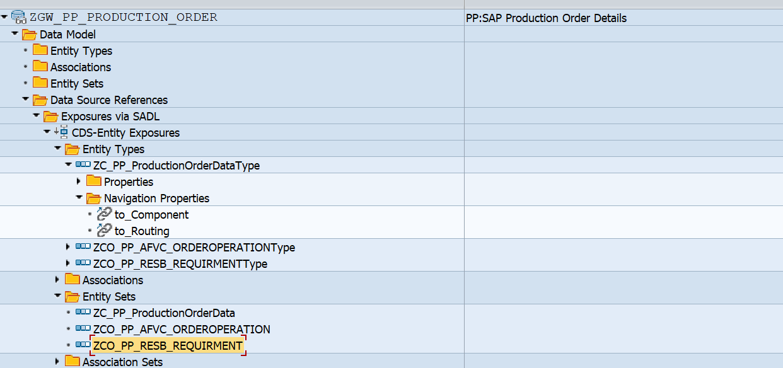

**Runtime Artifacts**

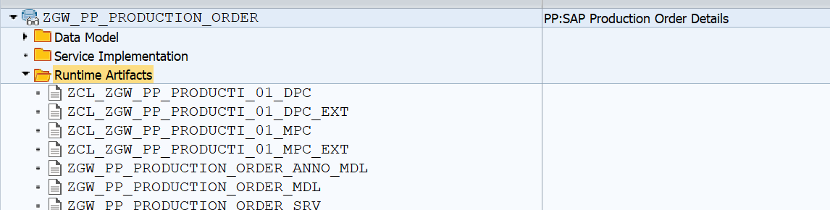

**4.Business API / OData API and Output Screen Screenshot:**

Here filtration is done based on AFKO table’s FTRMI(Actual release date) and in the Entity set that field name is also named as **‘ActualReleaseDate’.**

**Tested API with Output Screenshot: :**

**Based on single date Parameter:**

/sap/opu/odata/sap/ZGW_PP_PRODUCTION_ORDER_SRV/ZC_PP_ProductionOrderData?$filter=ActualReleaseDate eq datetime'2025-07-02T00:00:00'

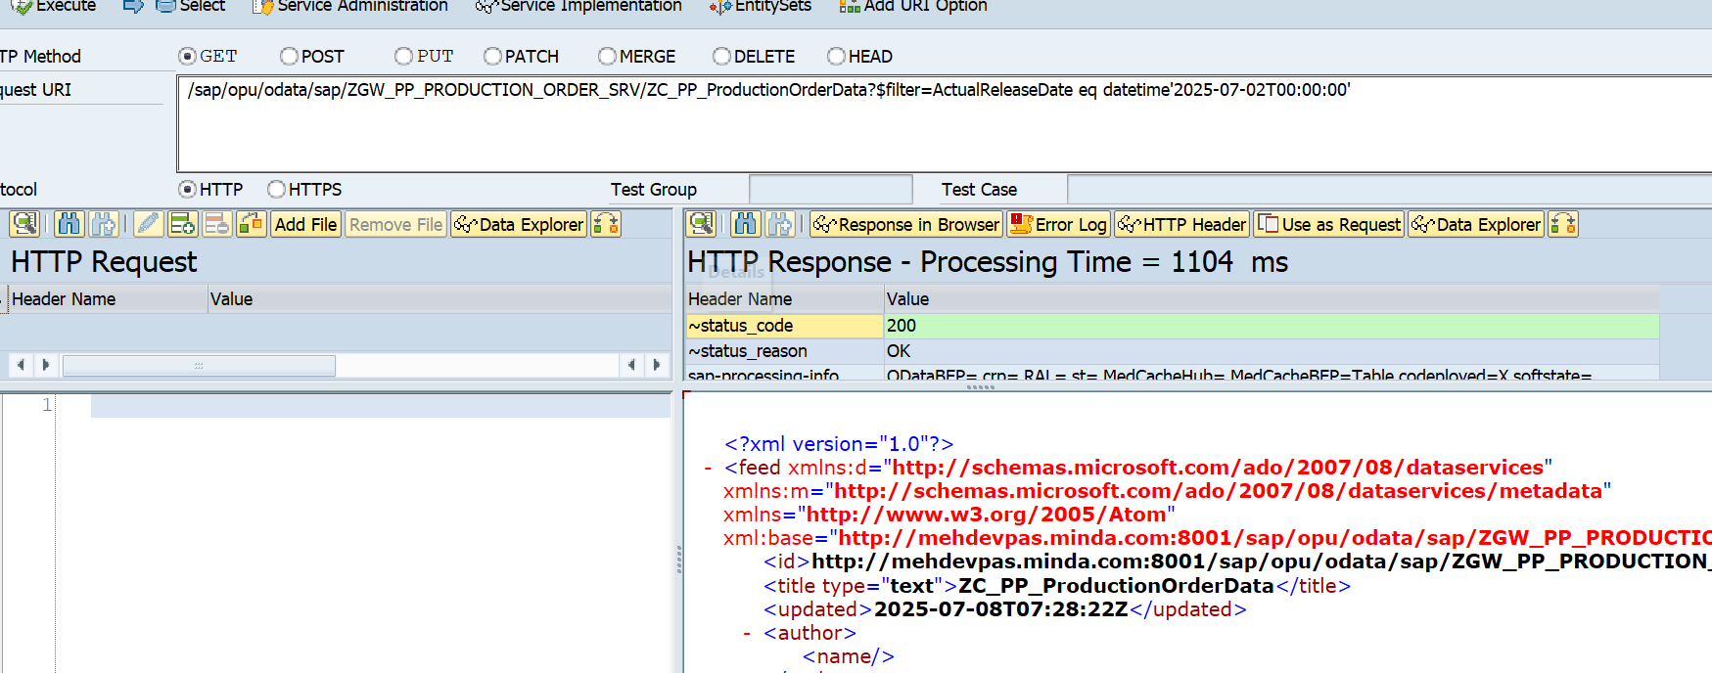

Count the number of record fetched based on the date filter:

/sap/opu/odata/sap/ZGW_PP_PRODUCTION_ORDER_SRV/ZC_PP_ProductionOrderData/$count?$filter=ActualReleaseDate eq datetime'2025-07-02T00:00:00'

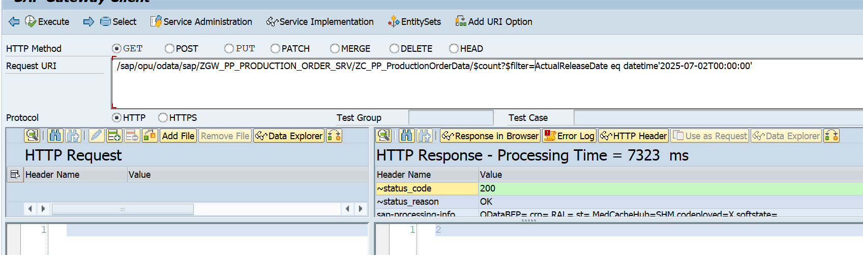

Verify the Above details with CDS for same Filter condition

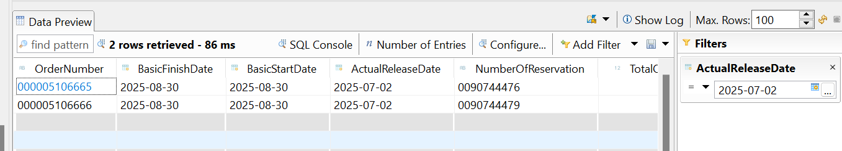

**Based On Select Option/Rang value passed in the filter condition field:**

/sap/opu/odata/sap/ZGW_PP_PRODUCTION_ORDER_SRV/ZC_PP_ProductionOrderData?$filter=ActualReleaseDate ge datetime'2025-07-02T00:00:00' and ActualReleaseDate le datetime'2025-07-07T00:00:00'

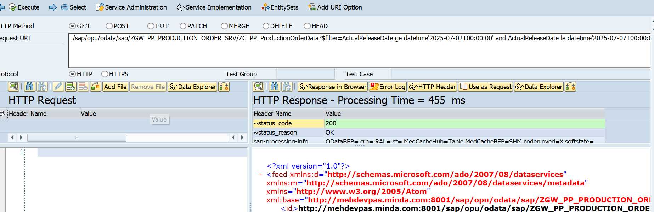

Count the number of record for this filter criteria:

/sap/opu/odata/sap/ZGW_PP_PRODUCTION_ORDER_SRV/ZC_PP_ProductionOrderData/$count?$filter=ActualReleaseDate ge datetime'2025-07-02T00:00:00' and ActualReleaseDate le datetime'2025-07-07T00:00:00'

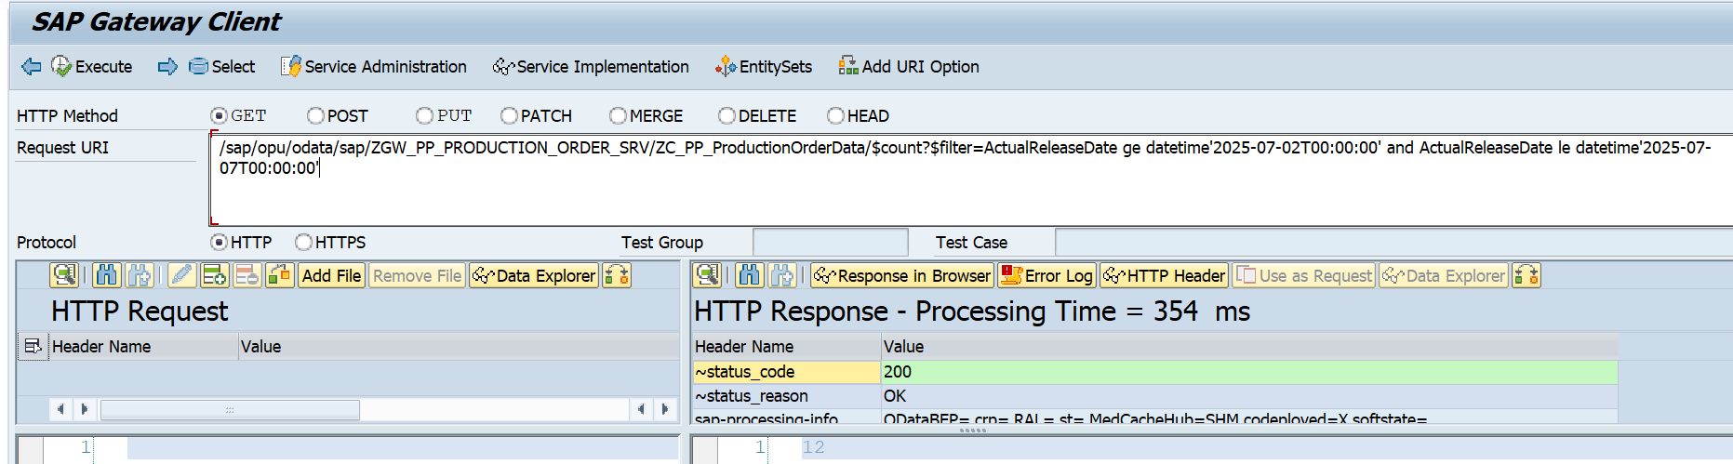

Database record check for this date range.

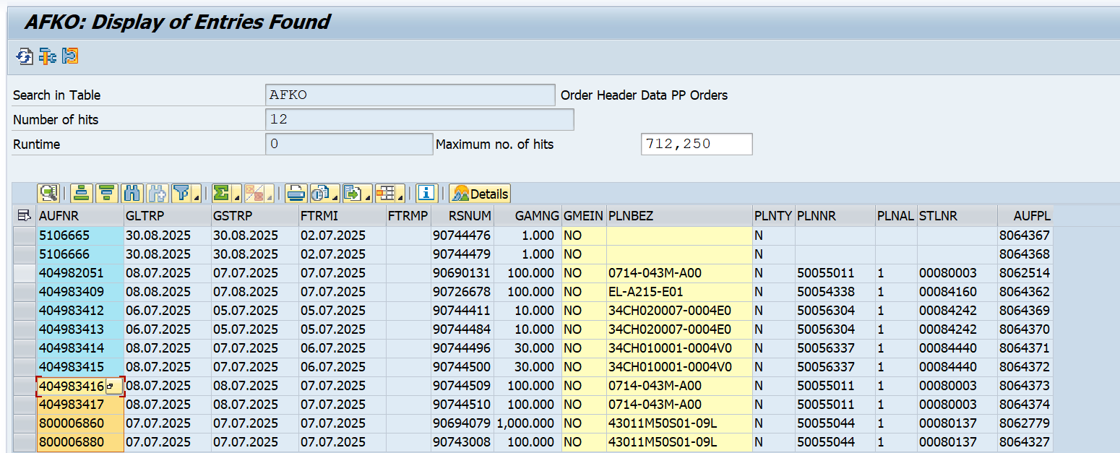

**For getting single order details based on Order Number**

/sap/opu/odata/sap/ZGW_PP_PRODUCTION_ORDER_SRV/ZC_PP_ProductionOrderData('000404983417')

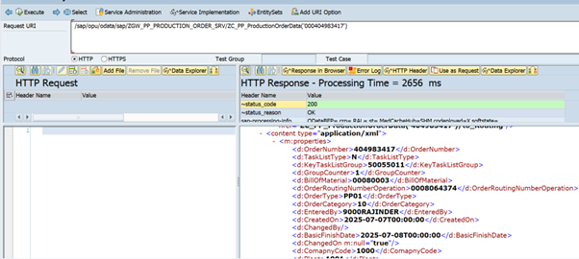

CDS Level data

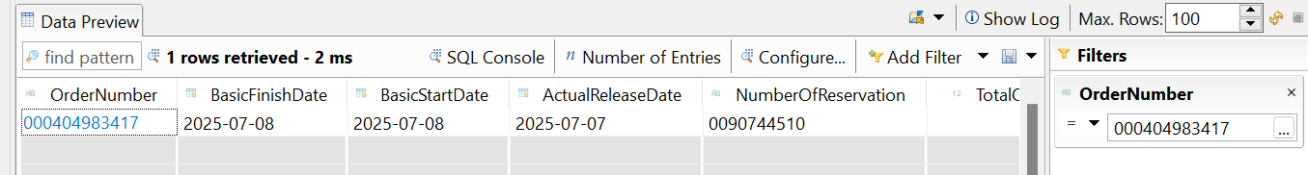

N**avigate to the Component details of the Production Order Number:**

/sap/opu/odata/sap/ZGW_PP_PRODUCTION_ORDER_SRV/ZC_PP_ProductionOrderData('000404983417')/to_Component

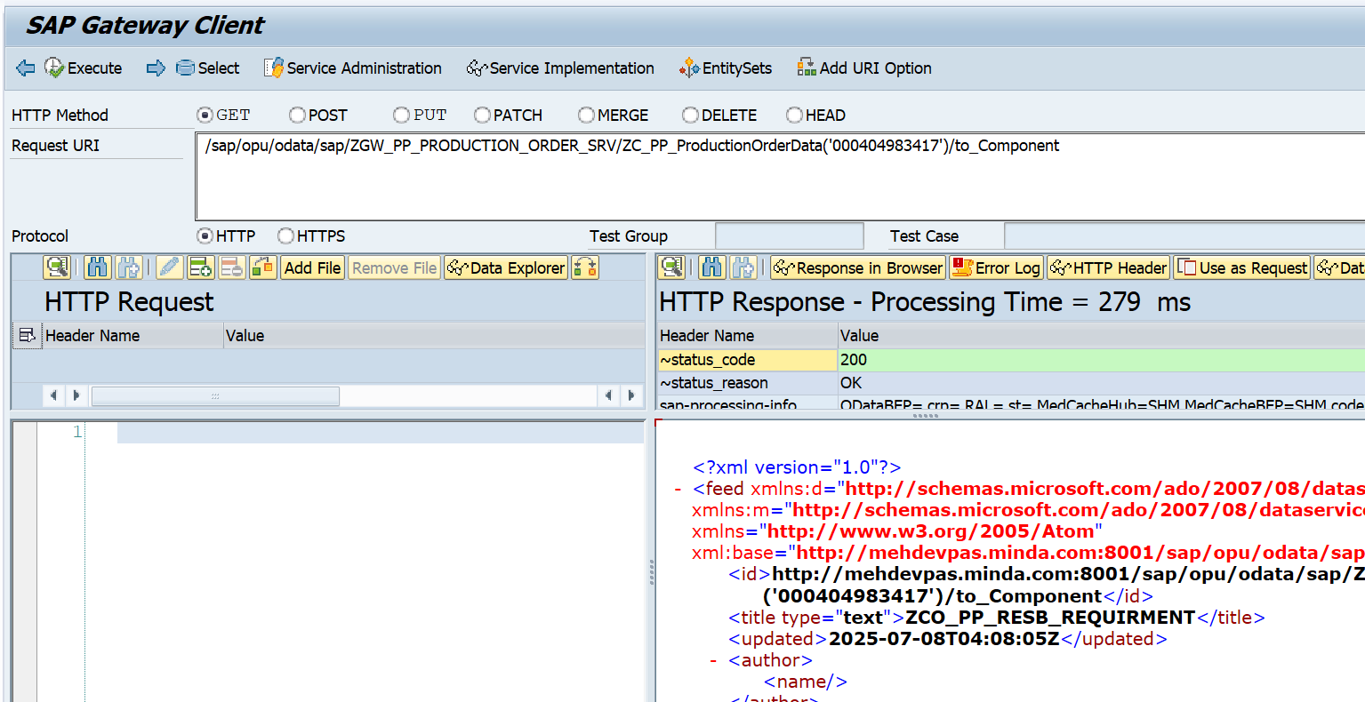

/sap/opu/odata/sap/ZGW_PP_PRODUCTION_ORDER_SRV/ZC_PP_ProductionOrderData('000404983417')/to_Component/$count

Postman API: http://11.1.3.57:8001/sap/opu/odata/sap/ZGW_PP_PRODUCTION_ORDER_SRV/ZC_PP_ProductionOrderData('000404983417')/to_Component?sap-client=190

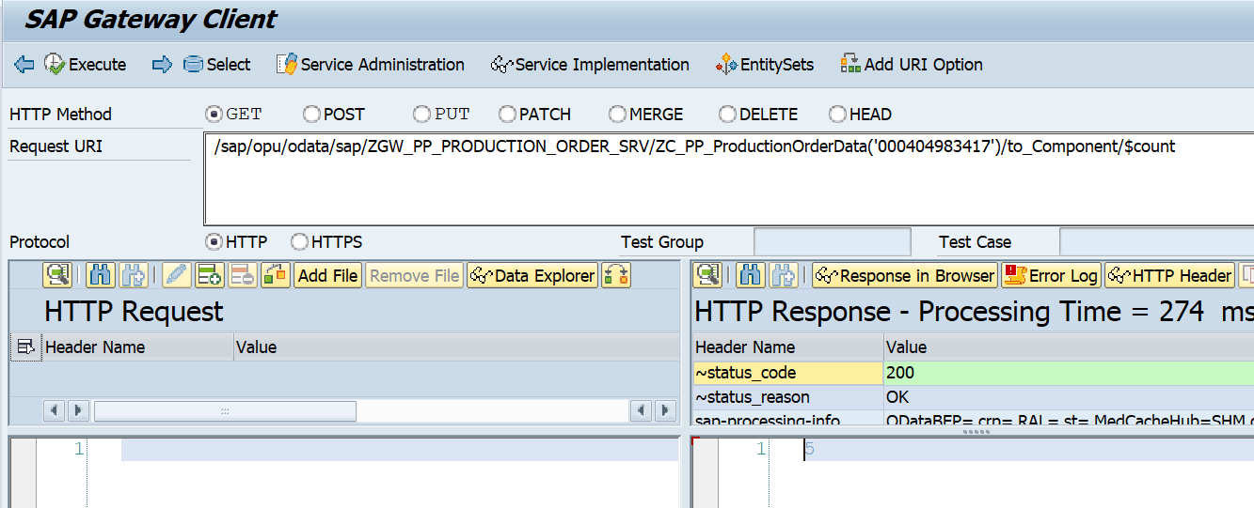

CDS level Data.

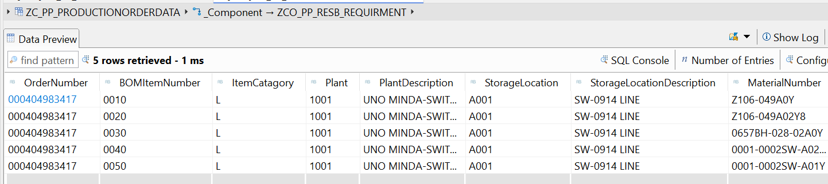

**Navigate to Routing Details of a Production Order Number:**

/sap/opu/odata/sap/ZGW_PP_PRODUCTION_ORDER_SRV/ZC_PP_ProductionOrderData('000404983417')/to_Routing

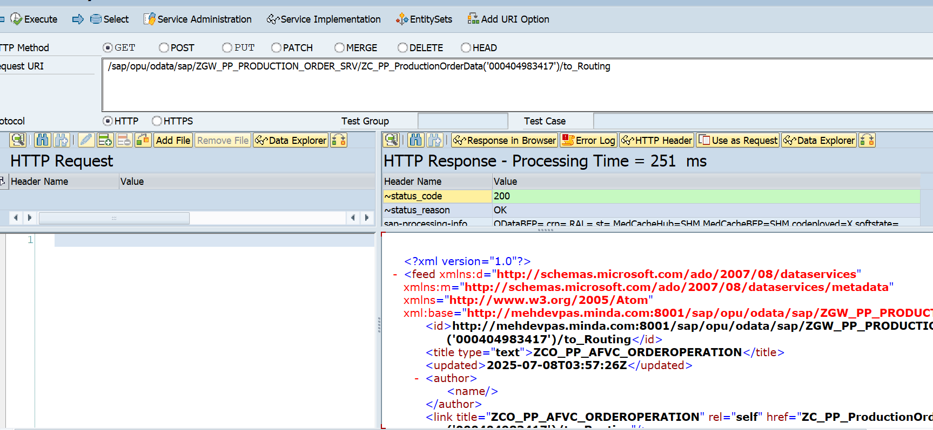

/sap/opu/odata/sap/ZGW_PP_PRODUCTION_ORDER_SRV/ZC_PP_ProductionOrderData('000404983417')/to_Routing/$count

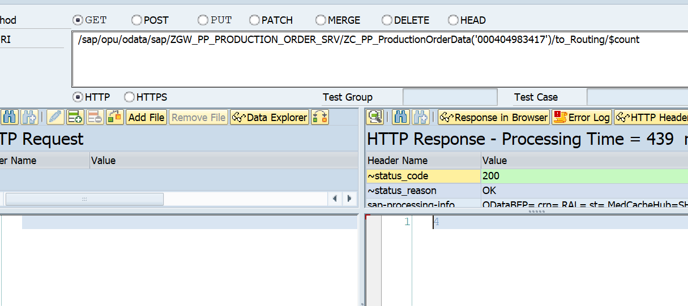

CDS level/Database level Data.

